Title of the research should be capitalized only the first word, concise and typed in single column (Times New Roman 14 Bold)

Firstname Lastname¹, Firstname Lastname², and Firstname Lastname^{3*}

^{1*}Affiliation of the first author
²Affiliation of the second author
³Affiliation of the last author; Corresponding author: e-mail: Name@institute.ac.th

ABSTRACT
Abstract (about 200 words) should be in single column and indicate the significant findings with data/data-range and conclusions of the paper. The manuscript should not exceed 4,000 words and 16 B5 pages (with top and bottom margin of 1 cm, left margin of 2.5 cm, right margin of 2 cm, and spacing between a column of 0.5 cm). Keywords (4-5 keywords) should be in single column and adequately index the subject matter. Font size for abstract, authors and affiliations, and keywords is Times New Roman 12.

Keywords: Keyword one, Keyword two, Keyword three

INTRODUCTION
(Times New Roman 12) should include precisely the aims of the study. It should be as concise as possible with no sub-headings. Exhaustive reviewing of literature should be avoided, only necessary and latest ones which are required to indicate the reason for the research undertaken and the essential background should be given.

(Times New Roman 12) should include precisely the aims of the study. It should be as concise as possible with no sub-headings. Exhaustive reviewing of literature should be avoided, only necessary and latest ones which are required to indicate the reason for the research undertaken and the essential background should be given.

METHODOLOGY
Method subtitle 1
(Times New Roman 12) should be sufficiently detailed to enable the experiments to be reproduced. The techniques and methodology adopted should be supported with standard references.

Method subtitle 2
(Times New Roman 12) should be sufficiently detailed to enable the experiments to be reproduced. The techniques and methodology adopted should be supported with standard references.

Method subtitle 3
(Times New Roman 12) should be sufficiently detailed to enable the experiments to be reproduced. The techniques and methodology adopted should be supported with standard references.

(Times New Roman 12) should be sufficiently detailed to enable the experiments to be reproduced. The techniques and methodology adopted should be supported with standard references.

RESULTS AND DISCUSSION
Result subtitle 1
(Times New Roman 12) should be either combined or separated. Results may be split into sub-headings. Data emerging out from the study should be included, arranged in the unified and coherent sequence and should be statistically analyzed. The same data should not be presented both in Tabular and Graphic forms. Only necessary tables and figures should be given. Long, confused and irrelevant discussion should be scrupulously avoided. It should deal with interpretations and the conclusions drawn, based on results and supported by relevant references. Repetition of data, statements and expressions should be curtailed.

(Times New Roman 12) should be either combined or separated. Results may be split into sub-headings. Data emerging out from the study should be included, arranged in the unified and coherent sequence and should be statistically analyzed. The same data should not be presented both in Tabular and Graphic forms. Only necessary tables and figures should be given. Long, confused and irrelevant discussion should be scrupulously avoided. It should deal with interpretations and the conclusions drawn, based on results and supported by relevant references. Repetition of data, statements and expressions should be curtailed.

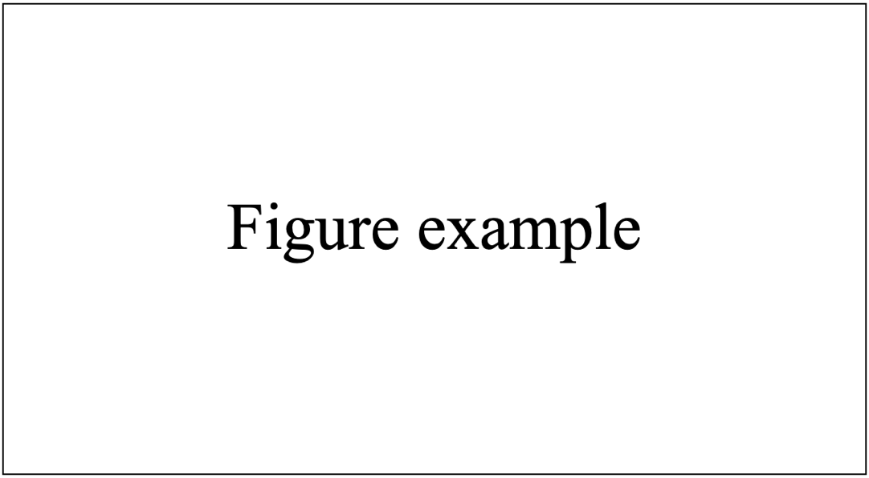
Figure 1 Title of the figure should be capitalized only the first word.

Result subtitle 2
(Times New Roman 12) should be either combined or separated. Results may be split into sub-headings. Data emerging out from the study should be included, arranged in the unified and coherent sequence and should be statistically analyzed. The same data should not be presented both in Tabular and Graphic forms. Only necessary tables and figures should be given. Long, confused and irrelevant discussion should be scrupulously avoided. It should deal with interpretations and the conclusions drawn, based on results and supported by relevant references. Repetition of data, statements and expressions should be curtailed.

(Times New Roman 12) should be either combined or separated. Results may be split into sub-headings. Data emerging out from the study should be included, arranged in the unified and coherent sequence and should be statistically analyzed. The same data should not be presented both in Tabular and Graphic forms. Only necessary tables and figures should be given. Long, confused and irrelevant discussion should be scrupulously avoided. It should deal with interpretations and the conclusions drawn, based on results and supported by relevant references. Repetition of data, statements and expressions should be curtailed.

Table 1 Title should be capitalized only the first word
Column 1 | Column 2 | Column 3
1 | 0.001 | 1
2 | 0.002 | 2
3 | 0.003 | 3

Result title 2
(Times New Roman 12) should be either combined or separated. Results may be split into sub-headings. Data emerging out from the study should be included, arranged in the unified and coherent sequence and should be statistically analyzed. The same data should not be presented both in Tabular and Graphic forms. Only necessary tables and figures should be given. Long, confused and irrelevant discussion should be scrupulously avoided. It should deal with interpretations and the conclusions drawn, based on results and supported by relevant references. Repetition of data, statements and expressions should be curtailed.

(Times New Roman 12) should be either combined or separated. Results may be split into sub-headings. Data emerging out from the study should be included, arranged in the unified and coherent sequence and should be statistically analyzed. The same data should not be presented both in Tabular and Graphic forms. Only necessary tables and figures should be given. Long, confused and irrelevant discussion should be scrupulously avoided. It should deal with interpretations and the conclusions drawn, based on results and supported by relevant references. Repetition of data, statements and expressions should be curtailed.

CONCLUSIONS
Summary of the conclusions from research findings.

ACKNOWLEDGEMENTS
Acknowledgements (Times New Roman 12) should include the names of those who contributed substantially to the work described in the manuscript but do not fulfill the requirements for the authorship. It should also include sponsorer/funding agency of the project of which the work described is a part.

REFERENCES
Andreozzi R, Caprio V, Insola A, Marotta R. 1994. Advanced oxidation processes (AOP) for water purification and recovery. Catalysis Today 53: 51-59.
Eisenberg, G. Colorimetric determination of hydrogen peroxide. Industrial and Engineering Chemistry, Analytical Edition 1943; 15(5): 327-328
Hassaan MA, Nemr AE. Health and Environmental Impacts of Dyes: Mini Review. American Journal of Environmental Science and Engineering 2017; 1(3): 64-67.
Puvaneswari N, Muthukrishnan J, Gunasekarn P. Toxicity assessment and microbial degradation of azo dyes. Indian Journal of Experimental Biology 2006; 44: 618-626.
Sellers, RM. Spectrophotometric determination of hydrogen peroxide using potassium titanium (IV) oxalate. The Analyst 1980; 105(1255): 950-954.

